|  |  |
| --- | --- |
| **Hedgehogs’ Termly Overview Autumn 2024** |  |

Dear Parents and Carers,

We are very pleased with how the children have settled into their new classroom and routines this term. What a fantastic new class of Hedgehogs’ we have, it is sure to be a busy and fun year!

Here is the overview for what we will be learning over the coming term. We hope that you find it helpful and informative. If you have any questions about your child’s school life or the curriculum overview, please don’t hesitate to arrange an appointment to speak to us.

Best wishes,

Mrs Barrett

Please ensure your child comes to school with the following named items every day.

* reading book and folder
* water bottle (containing water only please)
* coat
* packed lunch (if they are not having a hot school dinner)
* suncream and hat (in good weather)

Additional items for specific days.

* **PE kit** – Mondays and Tuesdays (black shorts, white t-shirt and trainers)

**In the interests of your child’s safety, it is essential that they have correctly fitting, suitable PE shoes. If they don’t, they will not be able to take part in the lesson. Long hair will need to be tied back and earrings removed (or covered). Thank you for your support with this.**

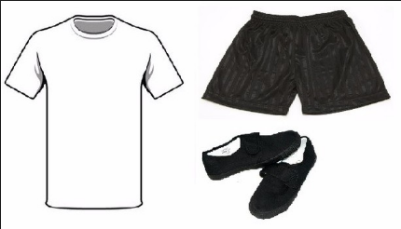

* Library book will need to be in school, in its plastic folder, to change on a **Wednesday**.

|  |  |
| --- | --- |
| **Homework Expectations** | |
| **English**  **Reading**  Please support your child to read regularly (at least 3 times a week) with an adult at home and keep a record in their reading diary.  Remember:   * Children being read to or with continues to have huge benefits even when they can read themselves! * Encourage a variety of text types * Talk about new vocabulary * Ask questions to develop comprehension.   Find the type of books your child loves.  Try different types of books.  Talk about new vocabulary  Ask questions to develop comprehension.  Class library books changed on Wednesdays. |  |

**Hedgehogs - Autumn Term 2024**

**Curriculum Overview - Information for Parents and Carers**

|  |  |  |  |
| --- | --- | --- | --- |
| **Maths**  We will be working on these areas:   * Place value * Addition * Subtraction | **English**  Writing will be linked to your child’s current Read Write Inc book | | **Science**  Living things and their habitats :  *Things that are living, dead or never been alive.  *Habitats  *Simple food chains |
| **RHE**  We will be exploring:   * Respecting Ourselves and Others * Families and Friendships | | **Geography**  *Maps, atlases and globes  *UK and its countries  * Continents and oceans of the world  North America: Physical Geography | **Computing**  Premium Vector | Portable Computer Laptop Clipart illustration*What is IT and how is it used? |
| **Art and Design**  Collage–  *Local Devon artist Clover Robins  *Collage techniques  * Creating textured paper for collage | **RE**  *Islam- Who is a Muslim and how do they live? | | **Music**  *Singing  *Pitch  91,700+ Music Clipart Stock Illustrations, Royalty-Free ...*Tuned percussion instruments |
| **PE**  This term, the children will be learning tag rugby skills and fundamentals of ball skills | | | |

