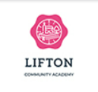
Dear Parents

Welcome back!

We are very happy and excited to see the children again. I was fortunate enough to know the children well through their time in the nursery and it has been fantastic to get to spend more time with them over the last couple of weeks.
Our theme this half term is ‘Who am I’? and we have lots of great learning opportunities planned. Please see overview attached.
Here are just a few reminders. Please could you send your child with a named water bottle each day and ensure your child has a forest school kit and named welly boots in school.
We are continuing to work on our children to be independent. Please can you help your child learn how to take their jumpers, coats and shoes and socks on and off.
If you have any questions or queries, please do not hesitate to speak to us.

Thank you for your continued support.
Mrs Kinger and Mrs Webber

Autumn Term 2024
Who am I?
Personal. Social and Emotional Development
This half term we will focus on settling the children into school and concentrating on supporting them to make positive relationships. We will be talking about our families, who we live with, our likes and dislikes as well as our feelings and experiences.

Communication and Language Development
The children will all have lots of opportunities to have quality conversations with adults in a language rich environment. The children will experience stories, non-fiction books, songs, rhymes and poems. The children will all be encouraged to share their experiences, ideas and thoughts throughout the day.

Physical Development
Robins will have weekly PE sessions where they can develop gross motor skills. This half term we are doing gymnastics. We also have weekly activities and resources available for children to develop their fine motor skills inside and outside the classroom. The children also have opportunities to use the large construction, bikes and create obstacle courses in our outdoor area.
Maths Development
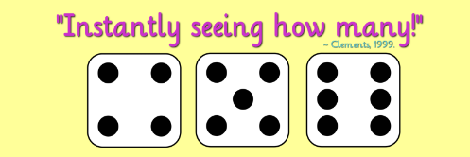
Robins have a combination of daily whole class maths activities as well as group work. There is also a number and a shape, space and measure activity which changes weekly. The children can be independent in this activity but there are also adults to support and/or move their learning forwards. This term we are working on consolidating their understanding of number, 1-1 counting with accuracy, subitizing to 5 and constructing and building with 3D solid shapes.

Literacy Development
Every half term we have ‘our favourite five’ books. This half term our favourite five books are ‘Oi Frog’, ‘Owl Babies’, ‘We are here’, ‘The Enormous Turnip and ‘The Kissing Hand’. The children have really enjoyed The Kissing Hand’ as the story resonates with many of them.
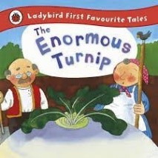
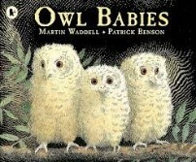
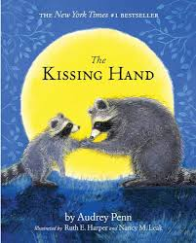
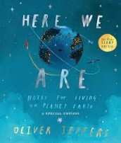 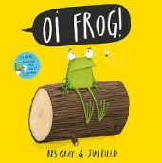
Robins have started learning their individual sounds and all children have made excellent progress. I am so impressed with their positive and enthusiastic attitudes to learning.
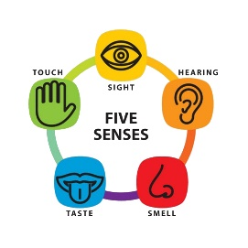
Understanding the World
Through lots of play in our garden and forest school area the children will learn about the weather, the changing seasons, our local wildlife and their habitats. Linked with our topic ‘Who am I’? we are also learning about our incredible bodies, what they are made up of and what they can do. Robins will also learn about the five senses and carry out fun activities to learn more about these.
Expressive Arts and Design
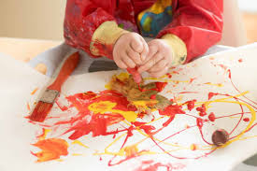
This half term we are looking at the artist ‘Mary Cassett’. She is an artist who draws people. Robins will be experimenting with mark making using a variety of media and learning how to draw people.
The children will always have access to a range of materials and media that they can use creatively as they wish.

