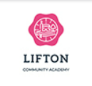
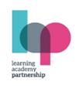

Dear Parents,
Welcome back!
We are very happy and excited to see the children again and welcome some new faces too.
Our theme for this half term is “Who Am I?” and we have lots of great learning opportunities planned. Please see the overview attached.
Here are just a few reminders, please could you send your child with a named water bottle each day and ensure your child has forest school kit and named welly boots in school.
We are also working on the children becoming independent. Please can you help your child become more independent by allowing and teaching them to put on their own velcro/ slip shoes and coat.
If you have any questions or queries, please do not hesitate to ask, or speak with us.

With thanks for your support.
Mrs. Webber and the team.

Autumn Term 2024
Who Am I?”
Personal Social and Emotional Development
This term we will focus on settling the children back into routines and concentrate on supporting them making positive relationships. During circle time talks we will encourage the children to think about who they are, their likes and dislikes, as well as their feelings and experiences.

Communication and Language Development
The children will all have lots of opportunities to have quality conversations with adults in a language rich environment. The children will experience stories, non-fiction books, songs, rhymes, and poems. The children will all be encouraged to share their experiences, ideas, and thoughts throughout each day.

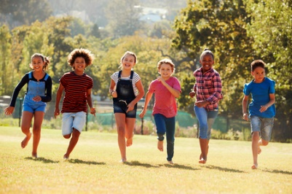
Physical Development
Children will also take in a variety of physical activities which involve both fine and gross motor skills during continuous provision. We enjoy gross motor skills by using the bikes, trikes along with the trim trail and bats and balls. Fine motor skills include treading, drawing and mark making also available in the continuous.

Literacy
Linked to our theme the children will be able to explore books and hear a range of stories about growing and learning new things. The children will regularly hear stories and be able to talk about them. Some examples of our chosen books are Owl Babies,
My Mum and Dad Make Me Laugh and You Choose.
Mathematics
The children will have daily maths activities. These will include counting and singing counting songs each day and working on problem solving activities, puzzles, shapes and counting.
The children will have counting objects to explore through their play, learning to touch each object as they count and understanding that the last number they reach is the number of objects there are.
As well as taking part in number activities we will carry out play activities linked to shape, space and measure.

Understanding the world
Through lots of play in our garden area and Forest school sessions the children will learn about the weather, the changing seasons, and different physical features in our local area.
The children will also learn about the similarities and differences between people and how this can be celebrated.

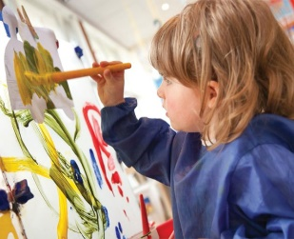
Expressive Art and Design
In Early Years we focus on the creative process not the product. The children will always have access to a range of materials and media through which they can express themselves in a creative and imaginative way. We also have the puppets and dressing up for the children to put on shows and singing with their peers.

